Experiment – 1A
Student Name: ABHISHEK KUMAR MISHRA UID: 24MCA20464
Branch: MCA Section/Group: 24MCA - 6B
Semester: 4 Date of Performance: 19 – 01 - 2026
Subject Name: Internet of Things Lab Subject Code: 24CAP-751

AIM:
Design first sketch to interface Led with Arduino Uno and to design different patterns.

OBJECTIVE:
- To understand the basic concept of interfacing an LED with Arduino Uno using a breadboard and current-limiting resistor.
- To study the role of digital input/output (I/O) pins of Arduino Uno for controlling external components like LEDs.
- To design and upload the first Arduino sketch for turning an LED ON and OFF.
- To implement different LED blinking patterns by using time delay functions in Arduino programming.
- To understand the working of control structures (looping and sequencing) used in Arduino sketches.
- To simulate and verify the LED interfacing and patterns using Tinkercad before implementing it on real hardware.
- To develop basic skills in embedded system programming and hardware–software integration.

Input / Apparatus Used
- Hardware Components
- Arduino Uno – Microcontroller board used to control the LED
- LED (Light Emitting Diode) – Output device for visual indication
- Resistor (220Ω / 330Ω) – Used to limit current and protect the LED
- Breadboard – For making temporary circuit connections
- Jumper Wires – For connecting Arduino pins to LED and resistor
- USB Cable – To connect Arduino Uno with the computer (for power and programming)

- Software / Simulation Tool
- Tinkercad – Used to design, simulate, and test the LED interfacing circuit and patterns
- Arduino Sketch (Program Code) – Used as input to control LED blinking and patterns

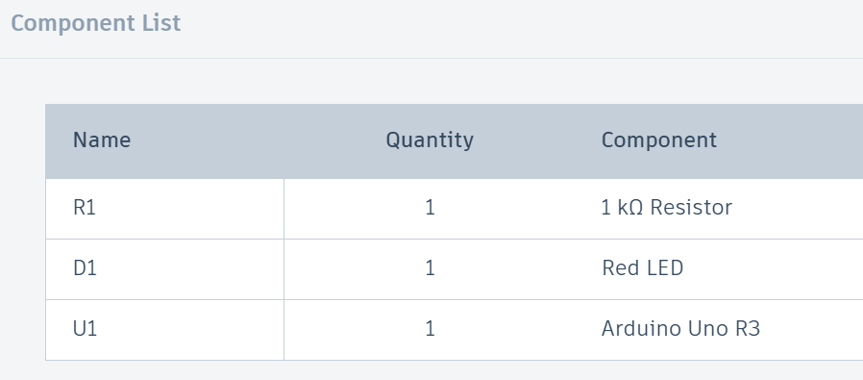

Circuit Diagram:

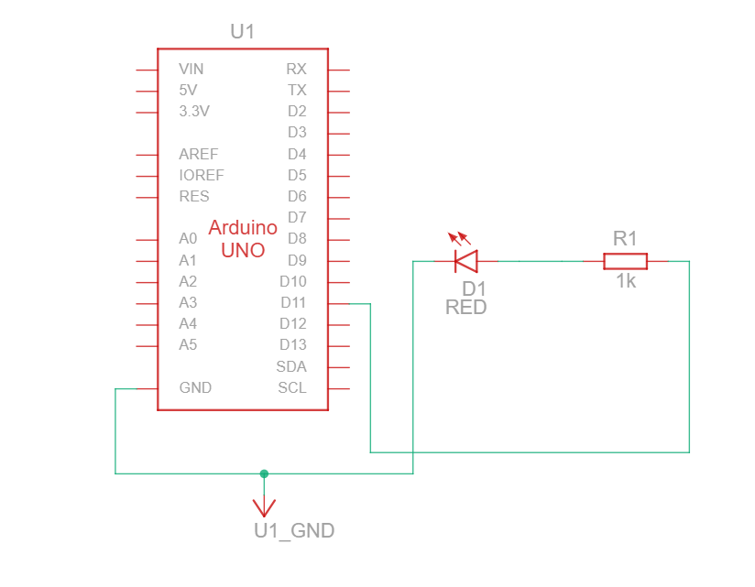

PROCEDURE:
This is the first program to be performed using the Tinkercad web app! The sequence of instructions will switch an LED connected to pin 13 of the Arduino, on and off, once every seconds.

- Open Tinkercad and create a new circuit.
- Place the Arduino Uno, breadboard, LED, resistor, and jumper wires in the workspace.
- Connect the anode (longer leg) of the LED to one of the digital pins (e.g., pin 13) of the Arduino Uno through a 220Ω resistor.
- Connect the cathode (shorter leg) of the LED to the GND (ground) pin of the Arduino Uno.
- Verify all the connections carefully to avoid short circuits.
- Write the first Arduino sketch to turn the LED ON and OFF using the digitalWrite() function.
- Upload the sketch to the Arduino Uno in the simulation environment.
- Observe the LED blinking to confirm successful interfacing.
- Modify the program by changing delay values and logic to create different LED blinking patterns (such as fast blink, slow blink, and sequential patterns).
- Run the simulation and observe the output for each pattern.
- Note down the observations and verify that the LED responds according to the written program.

Program for simulation:
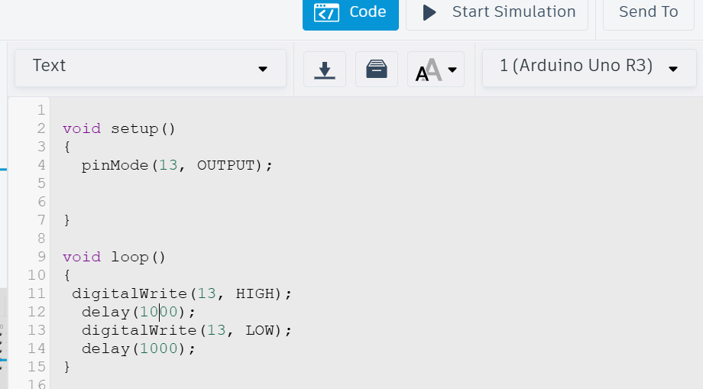

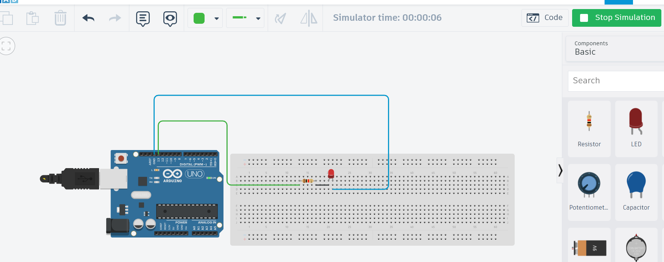
Output / Observation:
REsult:
- The LED was successfully interfaced with the Arduino Uno using digital pin 13.

- After uploading the program, the LED turned ON for 1 second and then turned OFF for 1 second, repeatedly.

- This blinking action occurred continuously due to the loop() function, confirming the correct use of pinMode(), digitalWrite(), and delay() functions.

- The observed output matched the expected result, verifying successful LED interfacing and basic Arduino programming.

- The circuit and code execution were successfully tested using Tinkercad.

LEARNING OUTCOMES:
- Interface an LED with the Arduino Uno using a digital output pin.
- Configure a digital pin as an OUTPUT using the pinMode() function.
- Control the ON and OFF state of an LED using the digitalWrite() function.
- Generate a 1-second blinking pattern by using the delay() function in Arduino programming.
- Understand the working of the setup() and loop() functions in an Arduino sketch.
- Verify program execution and hardware behavior through simulation using Tinkercad.
- Develop basic understanding of microcontroller-based embedded systems and timing control.

